

| **Title: Implement spatial data analysis in QGIS** |
| --- |

# Course Outcome:

# CO2 Apply the data analytics in the field of geospatial system

# Books/ Journals/ Websites referred:

# QGIS Version 3.38-Vector Data Code File-World.shp

# Resources used:

google

qgis

______________________________________________________________________

# Algorithm: Spatial Data Analysis

# Spatial Data type: Vector Data

# Step 1: Load Your Vector Data

# Open QGIS.

# Add your vector layer: Go to Layer > Add Layer > Add Vector Layer... and browse to your shapefile or other vector data.

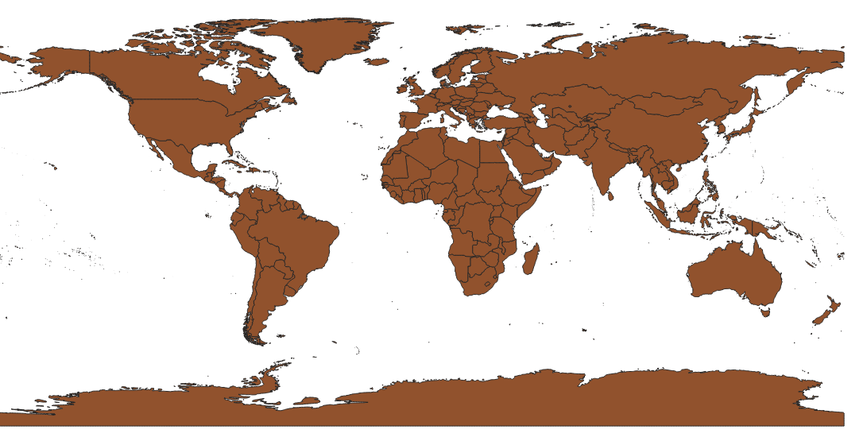

# Step 2: Open the Attribute Table

# Right-click on the layer in the Layers panel.

# Select Open Attribute Table.

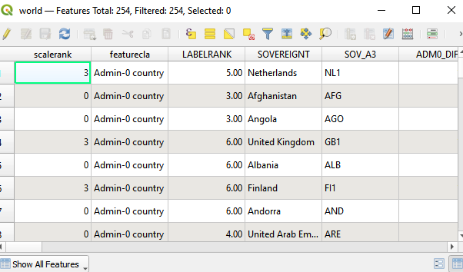

# Step 3: Add a New Field for Calculations

# In the attribute table, click on the Field Calculator icon (it looks like an abacus).

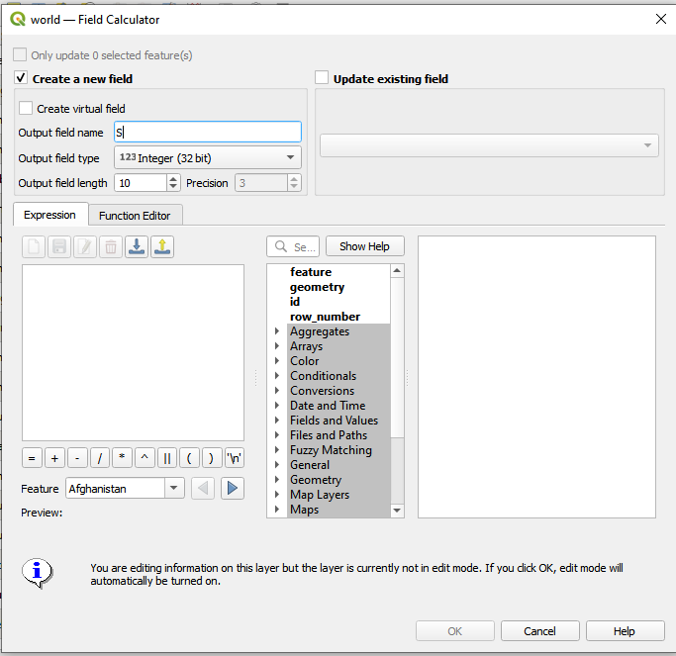

# Step 4: Calculate Area

# In the Field Calculator dialog:

# Check the option Create a new field.

# Enter a name for the new field (e.g., "Area").

# Set the output field type to Decimal number (real).

# In the Expression field, enter the following expression to calculate the area in square meters:

# $area

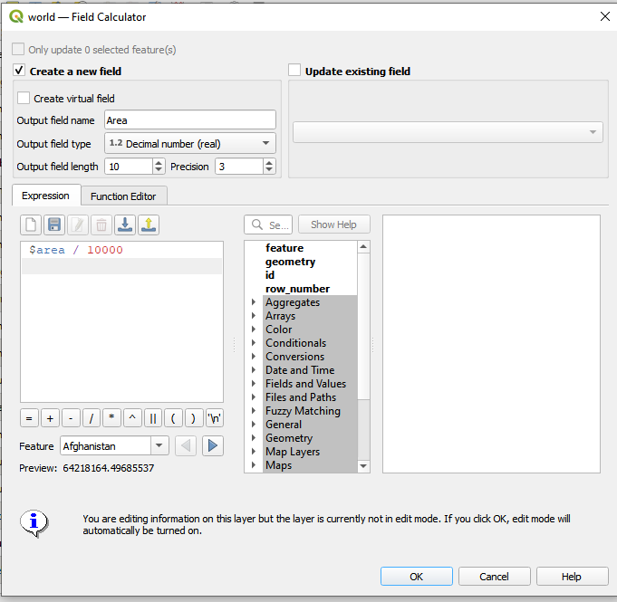

To get the area in hectares:

$area / 10000

Click OK to create the new field and calculate the areas.

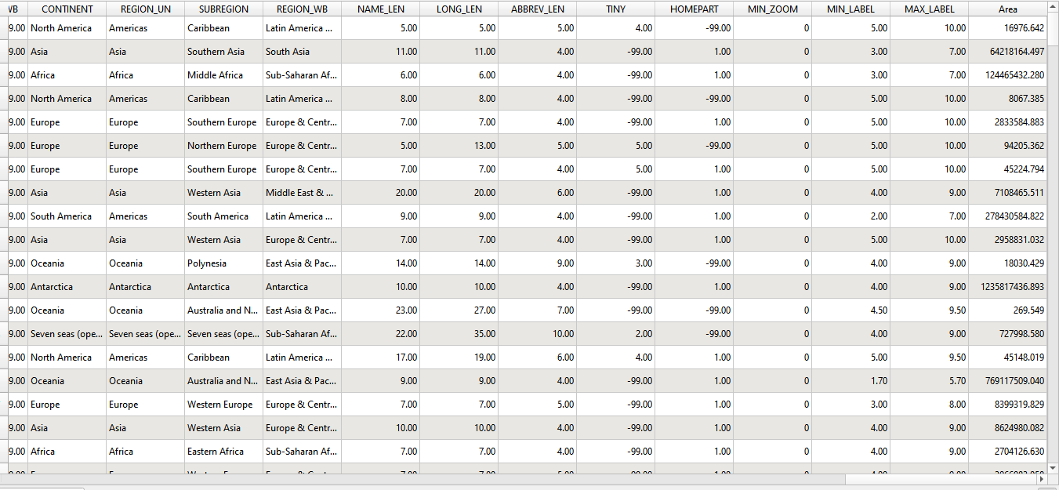

Step : Calculate Perimeter (for polygons):

perimeter($geometry)

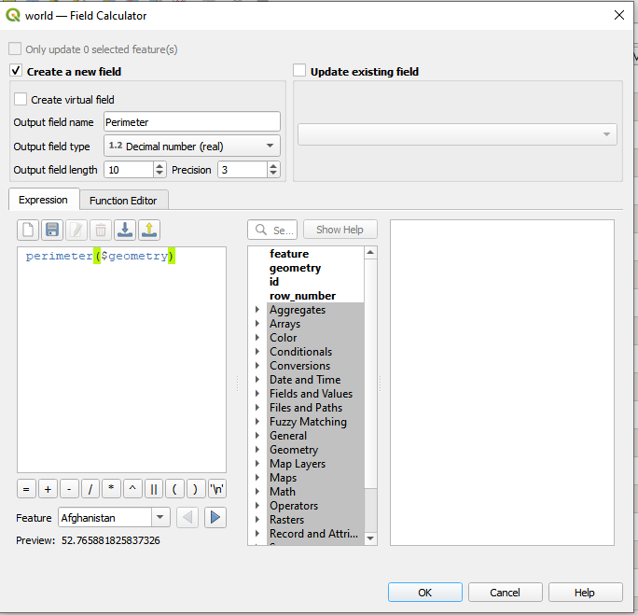  
  
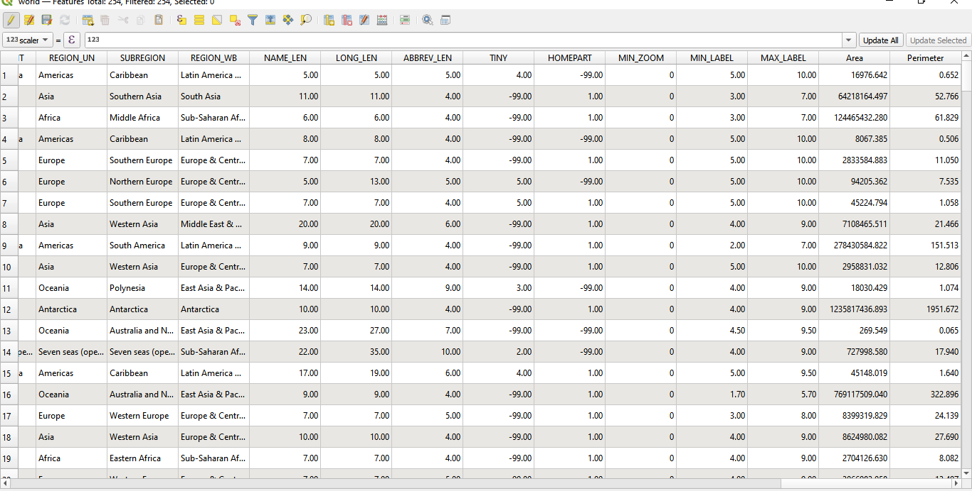

**Task: To work on other geometric properties like centroid using different expressions in the Field Calculator.**

**centroid  
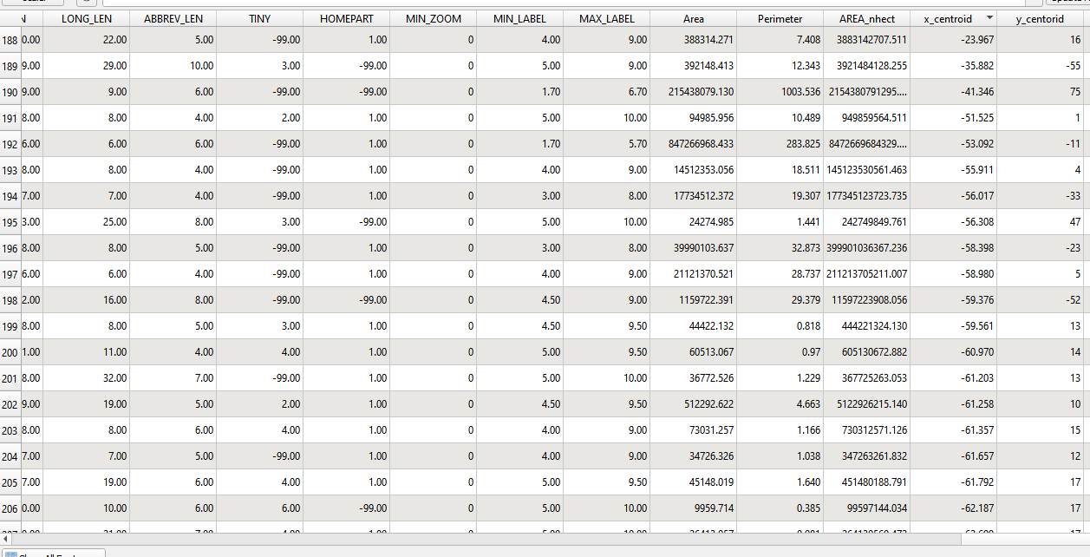**

**length ( null because it works for line not for vectors).  
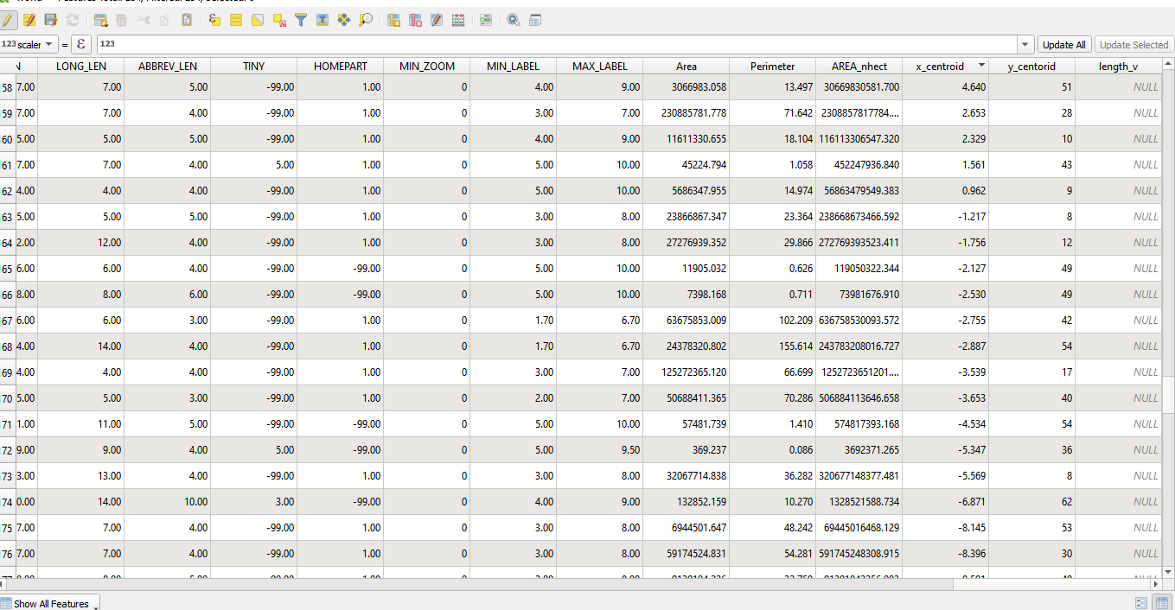**

**centroid with overlapping x and y axis  
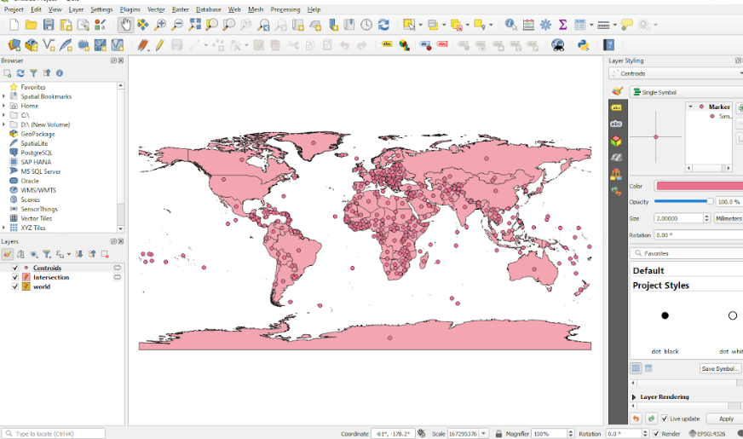**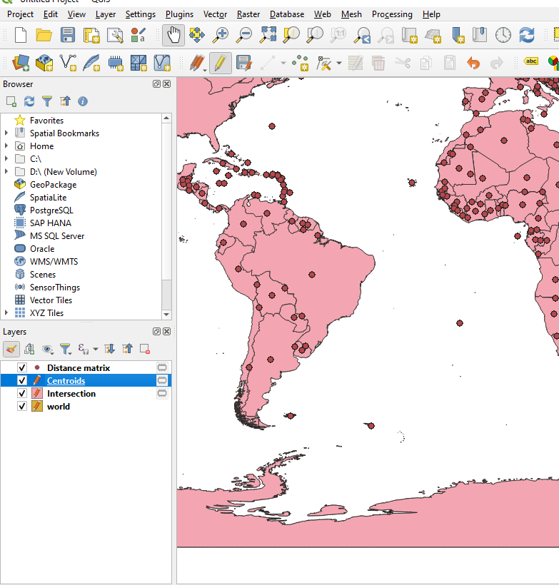  
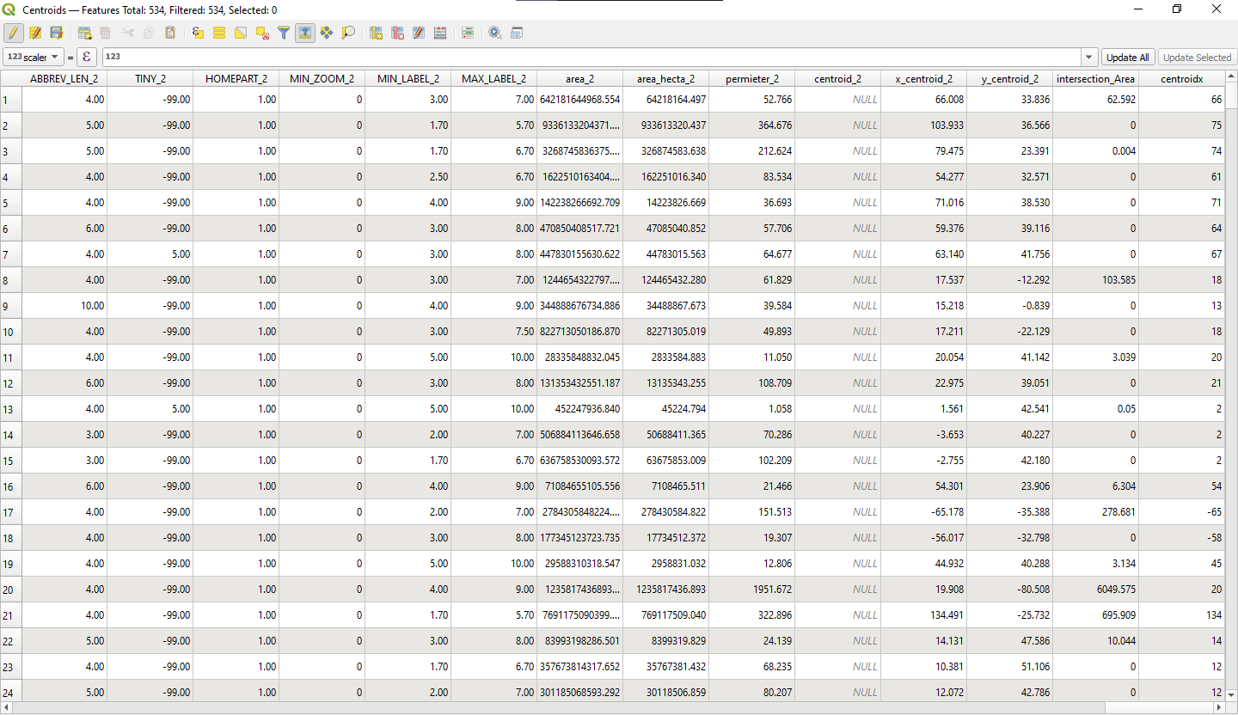

**intersecting area  
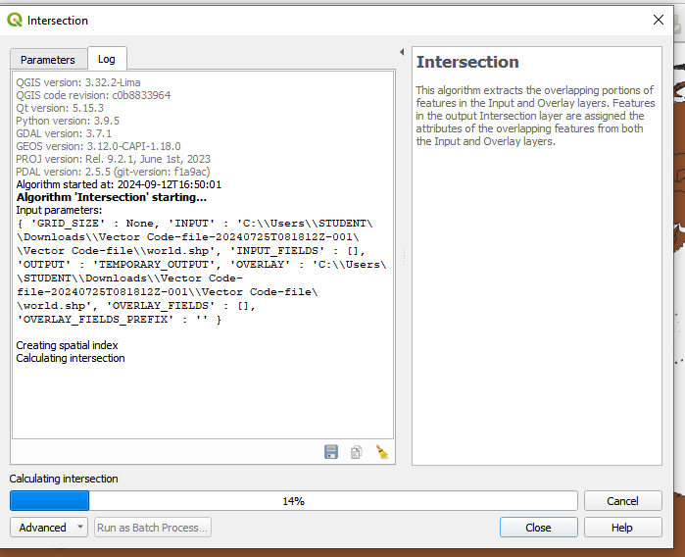  
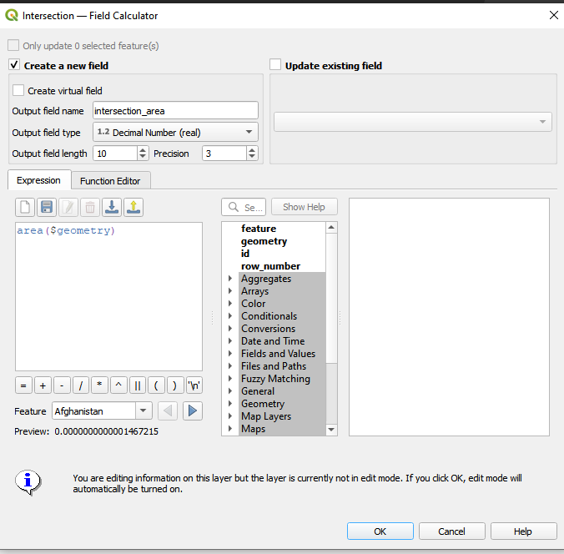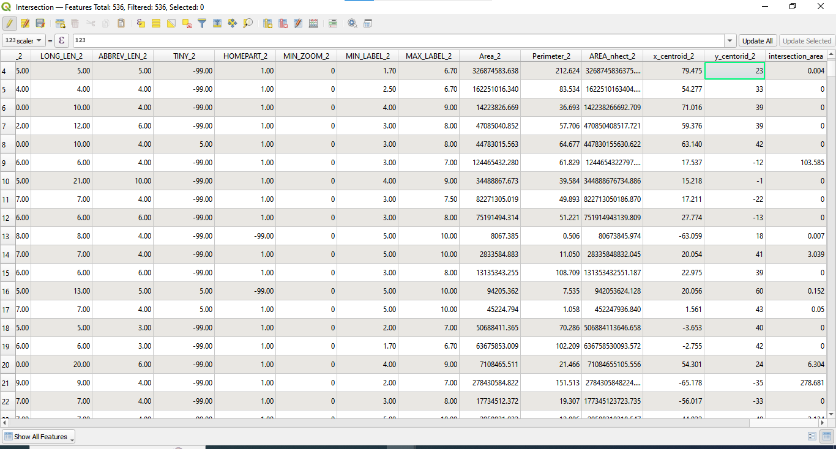**

# Platform used by the student: QGIS

# Following points should be written by students

# Different Geometric Properties used in spatial data analysis.

* Area- area($geometry) - Measures the size of a polygon’s surface.
* Perimeter: perimeter($geometry) -Measures the total length of a polygon’s boundary.
* Length: length($geometry) - Measures the total length of a line feature.
* Centroid: centroid($geometry) - The geometric center of a feature.
* Distance: distance($geometry, other_geometry) - Space between two features.
* Intersection: intersection($geometry, other_geometry) -Overlapping area or line between features.
* Union: union($geometry, other_geometry) -Combination of multiple geometries into one.
* Difference:difference($geometry, other_geometry) -Area or line remaining after subtracting one feature from another.

# Conclusion (Students should write in their own words):

Learnt field calculator in QGIS.

**Post lab questions:**

**Q.1 What are different geometric properties used in spatial data analysis on vector data with expression?**

* Area: area($geometry)
* Perimeter: perimeter($geometry)
* Length: length($geometry)
* Centroid X Coordinate: x(centroid($geometry))
* Centroid Y Coordinate: y(centroid($geometry))
* Bounding Box: boundingBox($geometry)
* Distance: distance($geometry, other_geometry)
* Intersection: intersection($geometry, other_geometry)

**Q.2 What are different geometric properties used in spatial data analysis on raster data with expression?**

* Raster Area: raster_area("raster_layer")
* Raster Perimeter: raster_perimeter("raster_layer")
* Raster Length: raster_length("raster_layer")
* Bounding Box: raster_bbox("raster_layer")
* Distance to Feature: distance(raster_layer, feature_layer)
* Intersection: raster_intersect("raster_layer1", "raster_layer2")
* Union: raster_union("raster_layer1", "raster_layer2")

**Q.3 What is spatial data analysis and write its advantages.**

Spatial Data Analysis involves examining geographic data to uncover patterns, relationships, and insights.

### Advantages:

* Enhances decision-making with spatial insights.
* Pattern Recognition: Reveals trends and spatial patterns.
* Resource Management: Optimizes resource allocation and management.
* Problem Solving: Addresses complex spatial issues.
* Efficient Planning: Supports better urban and environmental planning.
* Risk Assessment: Assesses spatial risks and hazards.
* Operational Efficiency: Improves route and location efficiency.
* Clear Visualization: Provides intuitive maps and visual data.
* Predictive Analysis: Forecasts future trends.
* Data Integration: Combines spatial data with other data types.